FIRST COAST CHAPTER
INTERNATIONAL CODE COUNCIL (ICC) AND
BUILDING OFFICIALS ASSOCIATION OF FLORIDA, INC. (BOAF)
SERVING BAKER, BRADFORD, CLAY, DUVAL, NASSAU, PUTNAM, ST. JOHNS & UNION COUNTIES

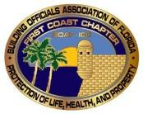 January 15, 2019

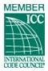
Dear Members and Interested Building Professionals,

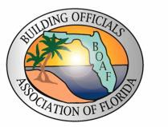
The First Coast Chapter Board of Directors is proud to report that membership and participation in our organization continues to increase. Many changes within our industry have heightened interest and sparked conversation. To this end, our organization has attracted a diverse group of professionals, which has enabled us to address a number of topics and disseminate information appropriately.

President
Dan Arlington,CBO
904.247.5813 darlington@coab.us

Vice President
H.T. White, CBO
904.827.6803 hwhite@sjcfl.us

2nd Vice President
Thomas Goldsbury,PE,CBO
904.255.8799
tomg@coj.net

Secretary/Treasurer
Kathleen Nichols
904.827.6805 jvogt@sjcfl.us

State Director
James Schock, PE,CBO
904.827.6806 jschock@sjcfl.us

Director
Floyd Simpson,PE
904.886.2401
fsimpson@HulsbergEngineering.com

Director
Charles Crain,CBO
904.827.6845 ccrain@sjcfl.us

Director
David Conner,CBO
904.269.6307
David.Conner@claycountygov.com

Immediate Past President
Robert Metcalf
904.255.8526 rmetcalf@coj.net

NOTICE FOR THE JANUARY MEETING

Date: 3rd Wednesday of each month.
Next meeting date – January 16, 2019
Time: 11:30 a.m. to 1:30 p.m. Location: Mandarin Ramada Inn
3130 Hartley Road (intersection of San Jose and I-295)

Cost: $10 lunch buffet (including tax and gratuity)

PRESENTATION:
“Inspecting Commercial Kitchen Hoods”
Presented by
Keith Jenkins, from CaptiveAire

We look forward to seeing everyone at the next meeting, and encourage continued participation and attendance.

